ASN:  submit a short report after the meeting, reporting on how the funds ($2500 US) were used and the names of the ASN student members who received direct support, if relevant.

The Ontario Ecology, Ethology, and Evolution Colloquium (OE3C) was held May 2-4, 2024 at the University of Waterloo. The OE3C is a provincial conference organized by (graduate) students for students that is hosted at a different university each year (founded in 1974). The primary aim is to provide young researchers with a platform to refine their communication skills, receive valuable feedback on their work, and network with local experts and peers.

A total of 139 participants (43 undergrad, 39 MSc, 34 PhD, 4 postdoc, 13 faculty, 4 industry, 2 unknown) from 14 universities and one private company attended OE3C 2024 and gave 106 presentations (37 undergrad, 31 MSc, 32 PhD, 4 postdoc, 2 faculty). A total of 11 undergraduate students and 23 graduate students attended for free thanks to your support. We were also able to decrease registration fees for students by 24.4% compared to last year ($170 this year vs. $225 in 2023) thanks to the support of our sponsors. Sponsors logos are displayed on our website, in the conference program, and shown on powerpoint slides during the conference.

We held a panel with Patricia Huynh, Sustainability project manager, University of Waterloo; Jean-Marc Daigle, landscape architect; and Brendon Samuels, PhD candidate Western University to discuss sustainability and biophobia. Keynote talks comprised Jessica Forrest, University of Ottawa; Hannah Ter Hofstede, University of Windsor; and Rebecca Doyle, McMaster University. The first day of OE3C consisted of excursions and one keynote talk. There was one off-campus excursion; a guided tour of [RARE charitable research reserve](https://raresites.org/) where participants learned about bumblebee radio telemetry, sustainable farming, and other research projects. Excursions on-campus comprised tree planting, bird banding, [WATER facility tours](https://uwaterloo.ca/biology/resources-and-services/water-facility), tours of the zoological collections, and the [earth science museum](https://uwaterloo.ca/earth-sciences-museum/).

We distributed an electronic survey to participants after the conference to solicit feedback and 18 responded. The conference was regarded as a fantastic experience for most respondents, with the welcoming atmosphere and organization of the conference being the most appreciated aspects. Most respondents left with a positive perception of the University of Waterloo and the Department of Biology, with many being inspired to consider new directions of research and appreciative of the opportunity to chat with people from different fields of study. Some suggested areas of improvement were better accommodation and food options, which will be taken into consideration for next year’s OE3C hosted at Carleton University.

We extend our heartfelt gratitude for your generous sponsorship, which significantly enhanced the accessibility of the conference for students. Your support played a pivotal role in making this event financially feasible for our student attendees. We deeply appreciate your commitment to empowering the next generation of scholars and ensuring their meaningful participation in our community. Thank you for making a difference.

Your support made the conference more financially accessible for students and we appreciate your sponsorship!

Of 142 attendees, 18 responded to the survey. The conference was regarded as a fantastic experience for most respondents, with the welcoming atmosphere and organization of the conference being the most appreciated aspects. Most respondents left with a positive perception of the University of Waterloo and the Department of Biology, with many being inspired to consider new directions of research and appreciative of the opportunity to chat with people from different fields of study. Some suggested areas of improvement were better accommodation and food options, which will be taken into consideration for next year’s OE3C hosted at Carleton University.

**From:** Karin Snyder [ed@cstws.ca](mailto:ed@cstws.ca), **Cc:** Peter Hettinga <treasurer@cstws.ca>  
The Canadian Section of the Wildlife Society, $250

We are also wondering if you would be willing to submit a small piece after the event to feature in our newsletter to members?  This might entail a simple blurb (couple sentences) of how the event went and how many people attended, etc, and possibly with a photo from the event or the logo.

We hope to see everyone at OE3C in 2025 at Carleton University.

Sustainability Panelists: Patricia Huynh, Sustainability project manager, University of Waterloo; Jean-Marc Daigle, landscape architect; Brendon Samuels, PhD candidate Western University

Keynote: Jessica Forrest, University of Ottawa; Hannah Ter Hofstede, University of Windsor; Rebecca Doyle, McMaster University

14 universities and one private company

139 attendees (43 undergrad, 39 MSc, 34 PhD, 4 postdoc, 13 faculty, 4 industry, 2 unknown)

106 presentations (37 undergrad, 31 MSc, 32 PhD, 4 postdoc, 2 faculty)

**OE3C 2024 Free Attendees:**

* 9 free UWaterloo undergrads + 2 undergrad committee (Mathumy, Harry)
* 19 free UWaterloo graduate students + 4 graduate committee (Beatriz, Lily, Michela, Ryan)

<https://www.oe3c.ca/>

twitter: @oe3c_official

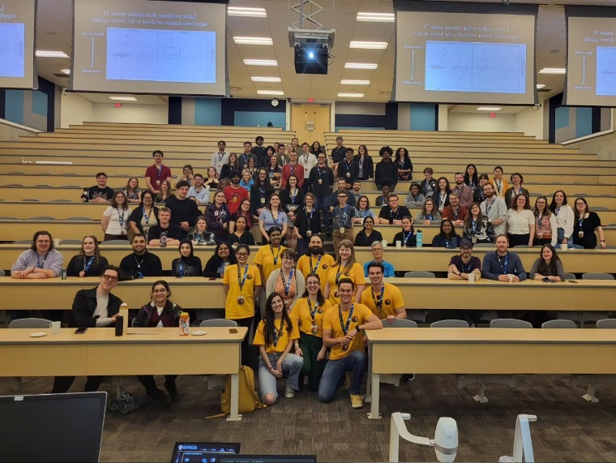

undergraduate & graduate students $170; decrease of 24.4%

postdoctoral researchers $200; decrease of 20%

faculty and professionals $225; decrease of 19.6%

2023 prices

undergraduate & graduate students $225

postdoctoral researchers $250

faculty and professionals $280